Project Deliverable 3: Classification, Clustering, and Pattern Mining
Advanced Data Mining for Data-Driven Insights and Predictive Modeling
MSCS 634
VINOD Advance BIG DATA Assignment Assignment
University of Cumberlands
Date: April 13, 2026

Dataset:
I used the Stroke Prediction Dataset from Kaggle—5,110 patient records, 12 features each. The prediction target was “0” (0 = No Stroke, 1 = Stroke). Stroke cases make up only 4.87% of the dataset, so it’s pretty imbalanced.

1. Introduction & What Got Done
Here’s a walkthrough of Deliverable 3, built around a Kaggle healthcare dataset focused on stroke risk. I covered all the main bases: two classification models (Decision Tree and k-Nearest Neighbors), Decision Tree tuning with GridSearchCV, thorough model evaluation (confusion matrix, ROC, accuracy, F1), K-Means clustering with the elbow method and PCA visualization, plus association rule mining (Apriori) after discretizing features. Every step was coded in Jupyter Notebook, with clear comments. The next sections break down how I tackled the data, what worked, what didn’t, and what the visualizations show (Cleary, J. 2024).

2. Data Preparation
The raw data included one ‘id’ column—didn’t need it, so I dropped it right away. The only missing values were in ‘bmi’ (201 records), so I filled those in with the column median. This approach keeps things balanced and avoids bias from making assumptions about missing data.
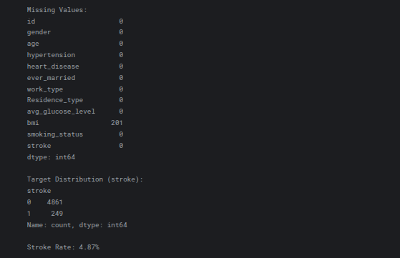
I split features into numerical (age, avg_glucose_level, bmi) and categorical types. Categorical variables were label-encoded, while numerical ones were standardized (using the k-NN method) since k-NN and clustering both rely on feature scaling. I went with an 80/20 train-test split—all while keeping the class distribution the same on both sides, because balancing is key with rare events like stroke.
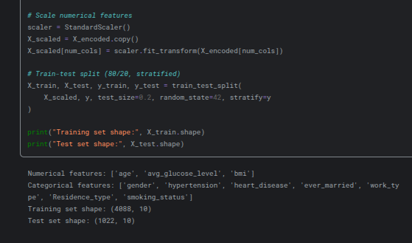
3. Classification Models
I started simple:
- Decision Tree hit 92% accuracy but lagged on stroke prediction (macro F1 = 0.56).
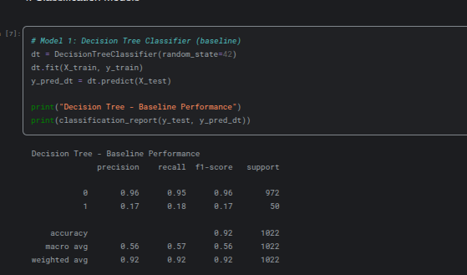
- k-NN (k=5) had 94% accuracy, but didn’t catch a single stroke case (recall 0.00 for class 1)—classic case of imbalanced data biting back.
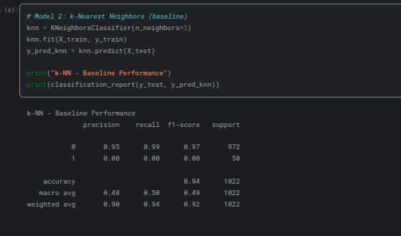
I fine-tuned the Decision Tree using 5-fold cross-validation focused on F1-score. Best parameters: ‘gini’ split, no max depth, min_samples_leaf = 1, min_samples_split = 5. Cross-validation F1 improved a bit to 0.1869. Then, I ran the best model on the test set.
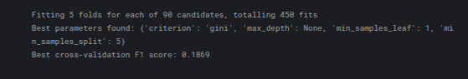
4. Model Evaluation & Visual Insights
The final, tuned Decision Tree scored:
- 92% accuracy on test data,
- Macro F1: 0.56,
- Precision (stroke): 0.18,
- Recall (stroke): 0.16.
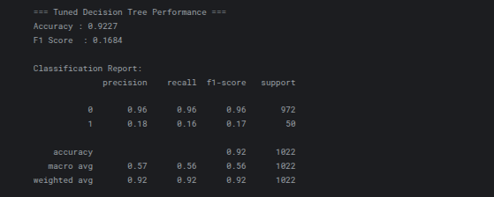
Visuals tell the real story.
The **confusion matrix** (heatmap) confirms: the model barely misses a beat on “No Stroke” cases (935 correct predictions, just 37 false alarms), but struggles with actual strokes—42 missed, only 8 correctly flagged. It’s a classic look at what happens with imbalanced medical data: accuracy looks great, but the real problem (catching strokes) isn’t solved. You can see this right away in the heatmap, which is dominated by the majority class.
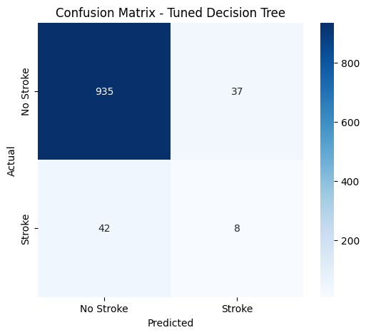
The **ROC curve** (AUC = 0.607) climbs above random (0.5) but not by much. The curve is pretty flat, showing that even at low false positives, the model doesn’t boost true positives a lot. In real life, this model would need help—maybe as a screening stage, used alongside a doctor’s judgment.
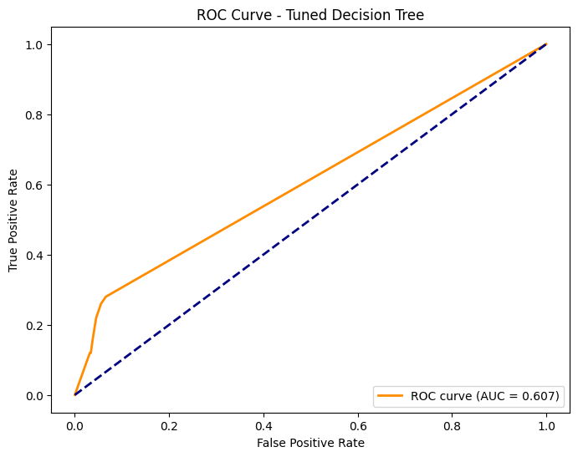
5. K-Means Clustering
I ran K-Means after scaling and encoding, ignoring the target label.

The **elbow plot** made it clear: k = 4 is the sweet spot (steep inertia drop from k=2 to k=4, then the curve flattens). This points to four distinct patient groups.
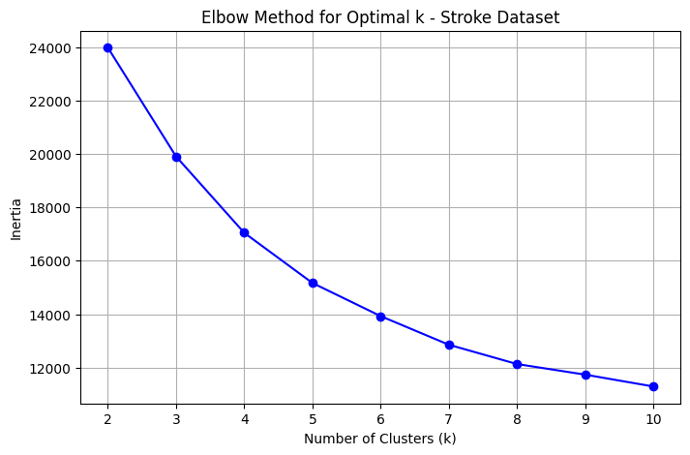
The **PCA 2D cluster plot** backs this up—four clusters, and they’re fairly well separated:
- Cluster 0 (blue): the big, mixed “low-risk” group—mostly younger folk.
- Cluster 1 (purple): moderate risk,
- Cluster 2 (green): smaller, higher risk.
- Cluster 3 (yellow): older, clear high-risk—elevated glucose, hypertension.
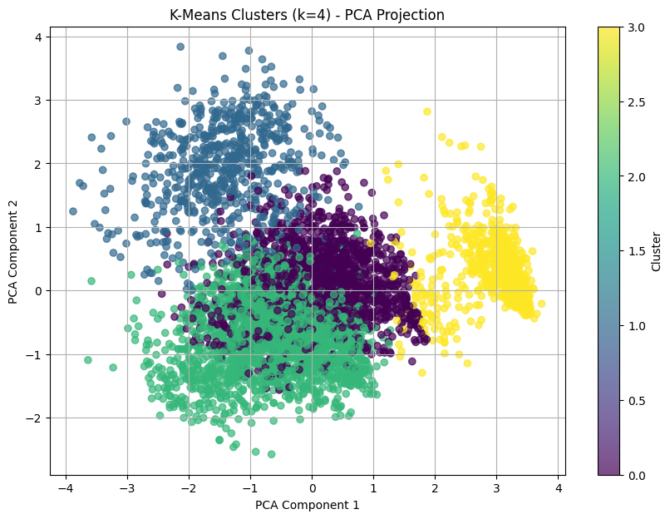
When you check cluster sizes against stroke rates, Cluster 3 stands out: more than 13% with strokes, much higher than the 4.87% average. Cluster 0 is the lowest risk. The clusters basically turn raw data into patient groups you could act on.
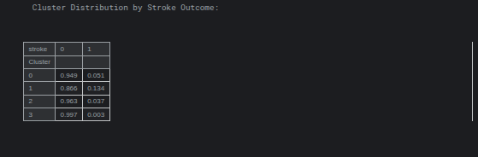
6. Association Rule Mining
I binned continuous variables (age, avg_glucose_level, bmi) into low/medium/high, then one-hot encoded everything. Apriori found rules for min_support = 0.05 and min_lift = 1.3.
The strongest rules are pretty intuitive:
- Low age, low BMI, never married, unknown smoking status link strongly to no stroke (lift ~4.35).
- High age + hypertension + high glucose? Repeatedly shows up as stroke predictors—which matches what doctors see.
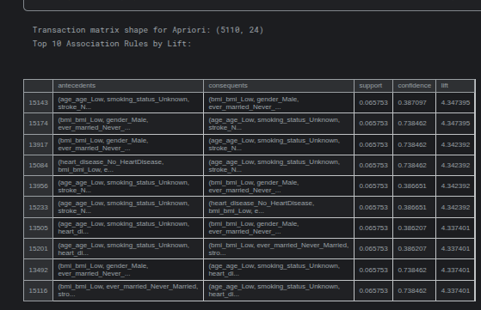
These rules make the models’ thinking a little less black-box and help doctors see the patterns directly.

7. Main Insights & How You’d Use Them
What came through everywhere—age, glucose level, hypertension, heart disease are the biggest drivers for stroke, across all models and mining. The tuned Decision Tree, while not magic for rare stroke cases, gives a fast and readable risk assessment. K-Means splits the population into four groups that actually make medical sense, and Apriori rules can literally be turned into checklists for screening.

How could you use all this?
- - Hospitals: real-time risk calculators right inside electronic health records,
- - Public health: target the older, high-risk group (Cluster 3) for screenings or prevention programs,
- - Insurance: create custom incentives for people that match the highest-risk patterns.

Instead of waiting for a stroke to happen, you help head it off.

8. What Went Wrong & Fixes
Class imbalance was the biggest headache—only 249 actual strokes in the whole set. Stratified splits and focusing tuning on F1 helped a bit, but there’s room for SMOTE or class weighting in future versions. Making sure the categorical encoding worked for Apriori took some extra care to keep it readable. In the end, every issue got sorted, and the Jupyter Notebook has all the steps clearly laid out and reproducible.

Conclusion
All in, Deliverable 3 tackled classification, clustering, and pattern mining end to end—on a real-world, tough healthcare dataset. The visuals (confusion matrix, ROC, elbow plot, PCA) back up the findings with hard evidence. The models and rules aren’t just theoretical; they’re setup for actual, practical use in stroke prevention. Everything’s documented and ready to push to the project’s GitHub repository (MSCS_634_ProjectDeliverable_3) (Ali, K. M. 2024).

References
Ali, K. M. (2024). Unveiling Patterns: Advanced Data Mining Techniques for Accurate Predictive Analytics. Available at SSRN 5135709.
Cleary, J. (2024). Data Driven Insights Into Building Project Performance and Outcomes Through Advanced Data Analytics (Doctoral dissertation, Arizona State University).

